**Scenario 1:**

**Scenario 2:**

We are unable to see **000**

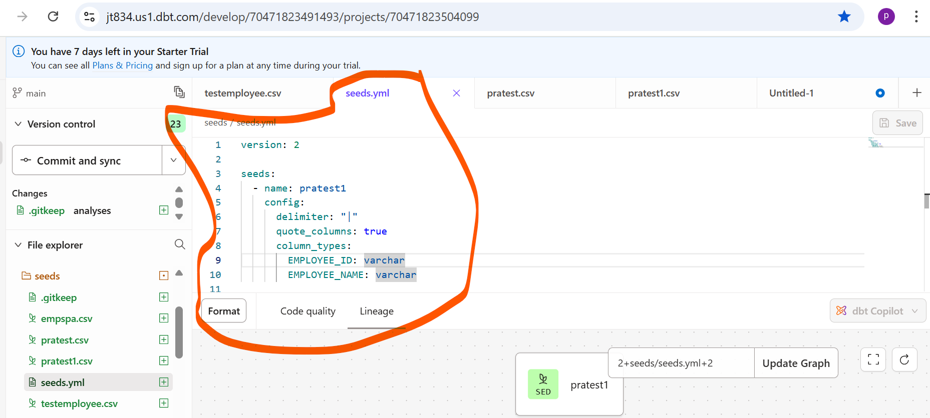

We can see **000**